* Hint: Answer all the following questions in “one word document named properly to reflect your name + course code with section + week of the course + file contents”. You might ask for help or search on the web to make sure you have provided correct answers before submitting your file.

Note: The answers are in ‘green’.

**Activity 1, integer overflow**

mid = (low + high) / 2; // **low**, **high**, and **mid** are all samesize integers.  
 (assume signed short int for your example: 0 – 32,767)

The above code was used to find the middle point in an array index for a binary search. Here is an animated example of a binary search in a sorted array: <https://www.cs.usfca.edu/~galles/visualization/Search.html>  
[note: numeric keypad input does not work, use the top row]  
[search: for the value at index position 20]  
[controls at the bottom allow you to adjust animation speed and steps]

1. 🡺What is potentially wrong with this line of code?

This line of code would probably work fine for small numbers which are less than the int maximum value(2^31-1) but it causes an overflow problem when the sum of low and high exceeds this value.The sum results in a negative number.

1. 🡺What values for low and high would cause an overflow problem?  
   [play with the integerOverflow.exe program in the zip file]

The values which cause an overflow problem are:-

high:2147483627

low:2147483620

or

high:2147483640

low:2147483699

1. 🡺How would you fix that line of code?

To fix the sum from getting a negative value, we subtract the large int low value from high, divide the answer by 2 and then add low.We may even check in advance if the values exceed the max value only then we can allow this line of code to run, otherwise the old line would run.

int mid = low + ((high - low) / 2);

<https://research.googleblog.com/2006/06/extra-extra-read-all-about-it-nearly.html> Nearly All Binary Searches and Mergesorts are Broken

**Activity 2, Boolean logic**

Do you have to go to school today for a class?OK, “yes” because you are here.

* **What is the Boolean logic to determine IF you should go to school on any day of the week?**

We assume that at least one day on your timetable has no scheduled classes.

The answer includes checking:

* today’s date and day-of-week
* which of your timetable days has classes?Or which day has no classes?
* [Academic date](http://www.senecacollege.ca/registrar/dates/academicdatesWinter2017.html) ranges. There are no classes during study week and the school is closed on holidays.

**IF**

**[(today's date >= 09/05/2017 AND today's date < 10/09/2017) > 0 OR (today's date**

**<10/09/2017 AND today's date >10/23/17) > 0 OR (today's date > 10/27/17 AND today's date<=12/08/17) > 0 ]**

**AND**

**[(DoW = Monday AND classesMonday) > 0 OR (DoW = Tuesday AND classesTuesday) > 0 OR (DoW = Wednesday AND classesWednesday) > 0 OR (DoW = Thursday AND classesThursdau) > 0 OR (DoW = Friday AND classesFriday) > 0 ]**

**THEN go to classes**

**Activity 3:Numbering Systems and Conversions**

In Microsoft Word, you can edit a font’s colour by adjusting its **Red**, **Green,**and**Blue**values. Each of these values can be any decimal number from 0 to 255. Using the following Hexadecimal values, determine what “web” colour would be produced.  
  
First convert HEX to decimal ( hex_nibble1 * 16 + hex_nibble2) and then use Font Color / More Colors…Customto adjust the RGB decimal values ): **(1 point)**

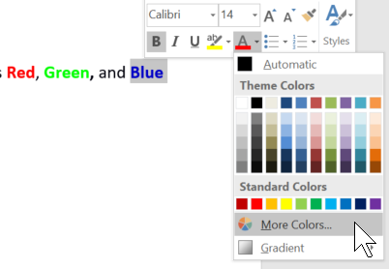 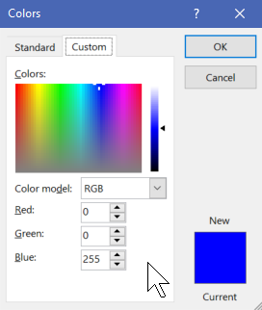

|  |  |  |  |  |
| --- | --- | --- | --- | --- |
| **3 Hex Codes** | **Red value in decimal (0-255)** | **Green value in decimal (0-255)** | **Blue value in decimal (0-255)** | **Final Colour** |
| #FFFFFF | 255 | 255 | 255 | White |
| #0000FF | 0 | 0 | 255 | Blue |
| #FFCCCC | 255 | 204 | 204 | Light Pink |
| #129823 | 18 | 152 | 35 | Dark Green |

What would the hex code be for the **following** colours?**(1 points)**

|  |  |  |  |  |
| --- | --- | --- | --- | --- |
| **Colour** | **Red value** | **Green value** | **Blue value** | **Hex Code** |
| Green | 0 | 255 | 0 | #00FF00 |
| Black | 0 | 0 | 0 | #000000 |
| Purple | 128 | 0 | 128 | #800080 |

**Activity 4:A typical Software Version**

Research and write the version number of software you use, such as a game, word processing, photo editing, etc. What does the version number mean? Include which parts are forward and/or backward compatible.**(1 point)**

**World of Warcraft, Patch 7.2.5**

**Developers would assign a unique version number to a software in order to represents its unique state of development and its order of the releases.**

**From the version number above, "7" represents a 'Major' revision, "2" represents a 'Minor' revision and "5" represents a micro revision.**

**7 and 5 (Major and Micro revisions) are both forward and back incompatible; which means, 7.2.5 could be forward compatible 8.2.6 (except 7.2.5 will not have the features of 8.2.6) and backward compatible with 6.2.5.**

**But, only the 2 (Minor revision) is backward compatible , but is not forward compatible. For example, 7.2.5 client will only be able to work on 7.1.5 (but new implemented features from 7.2.5 will be missing while running on 7.1.5), but 7.1.5 won't be able to run on 7.2.5 whatsoever.**